EXPERIMENT 15:

Complex number addition, subtraction, and multiplication.

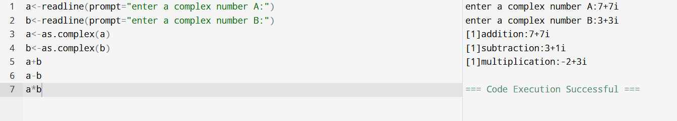

EXPERIMENT 16:

Sum of square of numbers.

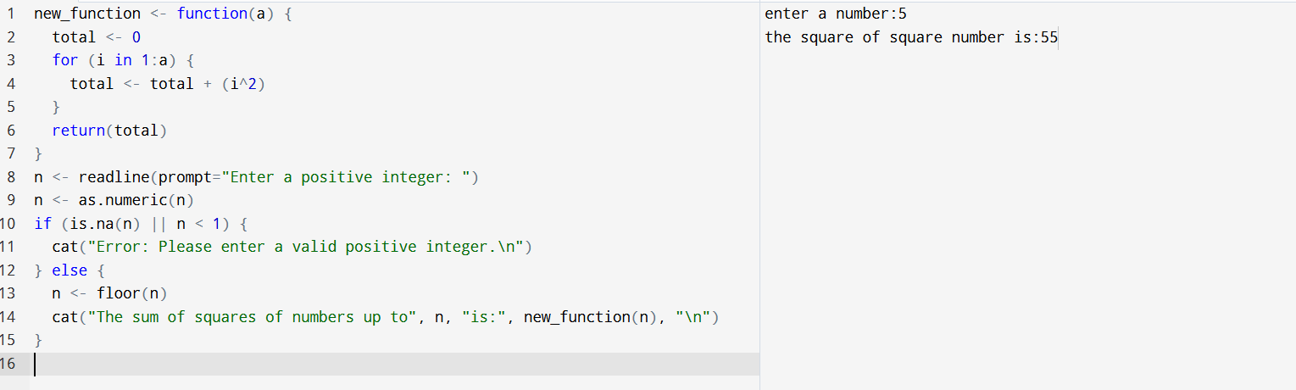

EXPERIMENT 17:

S3 CLASS- student details.

